Assignment- 11

1).Create an HTML page that uses Bootstrap utility classes to add 3 different levels of spacing (margin and padding) around a card displaying a Flipkart-style product image and name.

Code:- <!DOCTYPE html>
<html lang="en">
<head>
<meta charset="UTF-8">
<meta name="viewport" content="width=device-width, initial-scale=1.0">
<title>Product Card</title>

<link href="https://cdn.jsdelivr.net/npm/bootstrap@5.3.8/dist/css/bootstrap.min.css" rel="stylesheet">
</head>
<body>

<div class="container">

<div class="card m-5 p-4" style="width: 300px;">

<div class="m-2 p-2">
<img src="https://via.placeholder.com/250"
class="card-img-top"
alt="Product Image">
</div>

<div class="card-body m-3 p-3">
<h5 class="card-title">Samsung Galaxy Smartphone</h5>
<p class="card-text">₹19,999</p>
</div>

</div>

</div>

</body>
</html>

Output:-
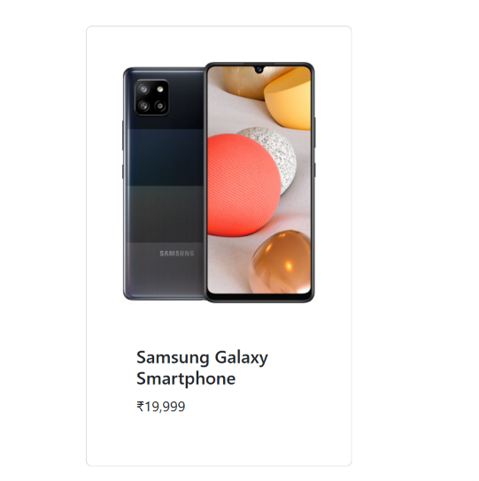

2).Build a movie review card (like BookMyShow) using Bootstrap typography utilities to style the movie title, rating, and review text with different font weights and sizes.

Code:-
<!DOCTYPE html>
<html lang="en">
<head>
<meta charset="UTF-8">
<meta name="viewport" content="width=device-width, initial-scale=1.0">
<title>Movie Review</title>

<link href="https://cdn.jsdelivr.net/npm/bootstrap@5.3.8/dist/css/bootstrap.min.css" rel="stylesheet">
</head>
<body>

<div class="container mt-5">

<div class="card p-4 shadow" style="max-width: 500px;">

<h2 class="fw-bold fs-2">
Avengers: Endgame
</h2>

<p class="fw-semibold fs-4 text-danger">
⭐ 9.2/10
</p>

<p class="fw-normal fs-6">
An amazing movie with great action, emotional moments,
and excellent performances. Definitely worth watching!
</p>

</div>

</div>

</body>
</html>

Output:-
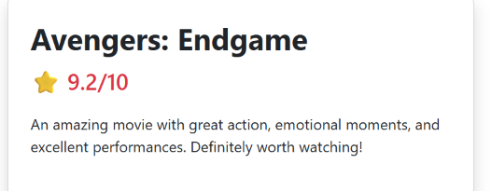

3).Design a Zomato-style restaurant list where each restaurant card uses at least three different Bootstrap color utility classes to highlight ratings, offers, and open/closed status.

Code:-
<!DOCTYPE html>
<html lang="en">
<head>
<meta charset="UTF-8">
<meta name="viewport" content="width=device-width, initial-scale=1.0">
<title>Restaurant List</title>

<link href="https://cdn.jsdelivr.net/npm/bootstrap@5.3.8/dist/css/bootstrap.min.css" rel="stylesheet">
</head>
<body>

<div class="container mt-5">

<h2 class="mb-4">Restaurants Near You</h2>

<div class="card p-3 mb-4 shadow-sm">

<h4>Spice Kitchen</h4>

<span class="badge bg-success">
⭐ 4.5
</span>

<p class="text-danger fw-bold mt-2">
50% OFF up to ₹100
</p>

<p class="text-success fw-semibold">
Open Now
</p>

</div>

<div class="card p-3 mb-4 shadow-sm">

<h4>Pizza House</h4>

<span class="badge bg-warning text-dark">
⭐ 3.9
</span>

<p class="text-primary fw-bold mt-2">
20% OFF
</p>

<p class="text-danger fw-semibold">
Closed
</p>

</div>

</div>

</body>
</html>

Output:-
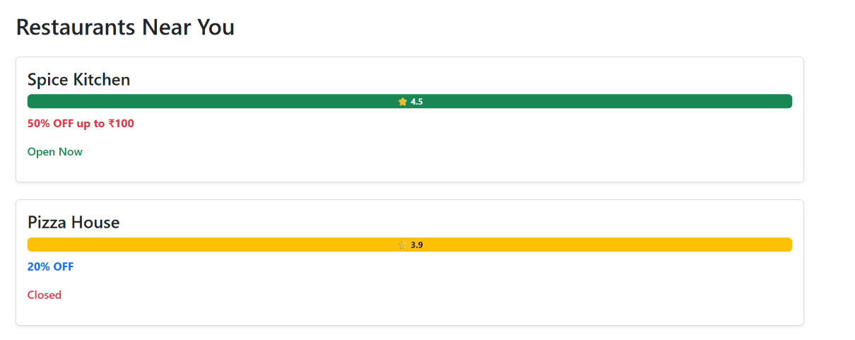

4).Override the Bootstrap primary button color in your own CSS file to use a custom shade (not the default blue), and apply it to a 'Book Ticket' button on your page.<br><br><em><strong>Hint:</strong> Use the CSS selector .btn-primary in your custom stylesheet and link it after the Bootstrap CSS.</em>

Code:-
<!DOCTYPE html>
<html lang="en">
<head>
<meta charset="UTF-8">
<meta name="viewport" content="width=device-width, initial-scale=1.0">
<title>Book Ticket</title>

<!-- Bootstrap CSS -->
<link href="https://cdn.jsdelivr.net/npm/bootstrap@5.3.8/dist/css/bootstrap.min.css" rel="stylesheet">

<!-- Our CSS must come AFTER Bootstrap -->
<link rel="stylesheet" href="style.css">
</head>
<body>

<div class="container mt-5">

<h2>BookMyShow</h2>

<button class="btn btn-primary">
Book Ticket
</button>

</div>

</body>
</html>
Output:-
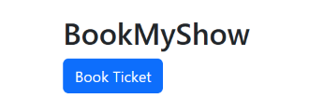

5).Add a theme switcher button to your page that toggles between a light and dark background using Bootstrap classes, and updates the text color for readability.<br><br><em><strong>Hint:</strong> Use JavaScript to toggle 'bg-light'/'bg-dark' and 'text-dark'/'text-light' classes on the main container.</em>

Code:-

<!DOCTYPE html>
<html lang="en">
<head>
<meta charset="UTF-8">
<meta name="viewport" content="width=device-width, initial-scale=1.0">
<title>Theme Switcher</title>

<link href="https://cdn.jsdelivr.net/npm/bootstrap@5.3.8/dist/css/bootstrap.min.css" rel="stylesheet">
</head>

<body>

<div id="mainContainer"
class="container-fluid min-vh-100 bg-light text-dark p-5">

<h1>Movie Booking Website</h1>

<p>
Welcome to our movie booking page. Select your favourite
movie and book your tickets.
</p>

<button class="btn btn-primary" onclick="changeTheme()">
Switch Theme
</button>

</div>

<script>

function changeTheme() {

let container = document.getElementById("mainContainer");

container.classList.toggle("bg-light");
container.classList.toggle("bg-dark");

container.classList.toggle("text-dark");
container.classList.toggle("text-light");

}

</script>

</body>
</html>

Output:-
